**Lab Sheet**

1. Staff will demo the editor to be used in the lab as this may vary across campuses. Also, any settings that may be useful.
2. Familiarise yourself with the HTML editor in your lab.
3. A zipped file called Files is on Moodle. These files contain sample HTML code of the elements/attributes covered this week. Download and extract these files:

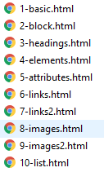

1. Open the first file, read the code and make sure you understand what it means. 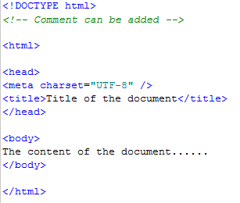
2. Open each file in turn to understand how it has been developed or changed to show different features eg <p> (paragraph), <h1> to <h6> (heading) tags, attributes such as href within <a> (anchor) tags, local and external links, images.
3. Create a new file and save it as index.html.
   1. Make sure you have the basic code for an html page.
   2. Insert your name as a level 1 heading.
   3. Insert your Banner ID as a level 2 heading.
   4. Insert at least 2 paragraphs and add text about yourself, interests, any work experience, what you would like to do in the future.
   5. Add at least 2 self-closing tags eg <br /> (line break), <hr /> (horizontal rule)
   6. Download some images from the Sample folder on Moodle to your images folder (create one if it doesn’t exist)
   7. Insert these images to your web page
   8. Google and source some copyright free images (careful of size)   
      eg. <http://www.imagesource.com/royalty-free>
   9. Download these images to your images folder
   10. Insert at least 3 images to your web page.
   11. Add at least 3 links to external sites of interest.
   12. Create an internal link to info.html (which you’ll create in the next step)
   13. Save your changes.
4. Create a new file and save it as info.html.
   1. Add your name and Banner ID as before.
   2. Insert at least 2 paragraphs and add more text about yourself.
   3. Create an internal link to index.html
   4. Add some comments and check that these are not displayed when the page is displayed in the browser
   5. Add at least 3 special characters eg £, ≤, ©
   6. Apply the style attribute to some of the tags which add the following:
      1. Background colour
      2. Text colour
      3. Different font
5. Create the following types of lists:
   1. Unordered list

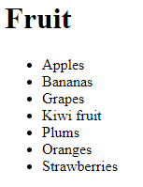

* 1. Ordered list

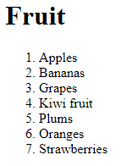

* 1. Nested list

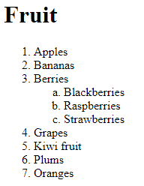

* 1. Lists with attributes

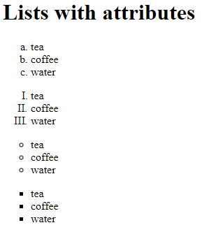

1. View each file in a browser and check the links work, the images, special characters, styles and lists are displayed properly.
2. Create new HTML files using the various elements and tags covered this week.
3. Save the files with appropriate names so that staff can check your progress.
4. Look at the html resources on <http://www.w3schools.com>
   1. Tutorials / Quiz Test
   2. Examples / References
5. Check out the ‘Cheat sheets’ on Moodle which can be useful references

